**Component Name**: User Details Form

**Component Functionality**:

Registration Form is an reusable component in react which has form features like input, select drop down, checkbox, text Area, buttons.

**Usage Areas**:

This reusable component can be integrated with different forms by passing required/specific data as its registration form with edit and remove option.

**Component Technical details**:

* React version: 16.13.1
* Bootstrap version: 4.5.0

We have a single component as App which is the parent component which renders rest of the components so as to process all the form fields, also we can perform edit and remove operation on the table.

**How this component can be integrated with other Applications**:

As it is a separate reusable component we need to import the same in our application wherever required to make use of the functionality.

**Screenshots**:

1. Initial Screen

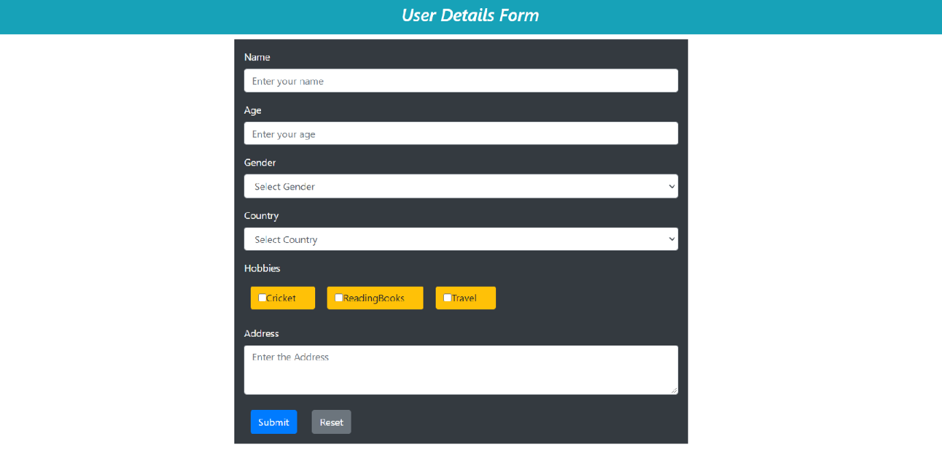

1. Screen where user enters all the form fields.

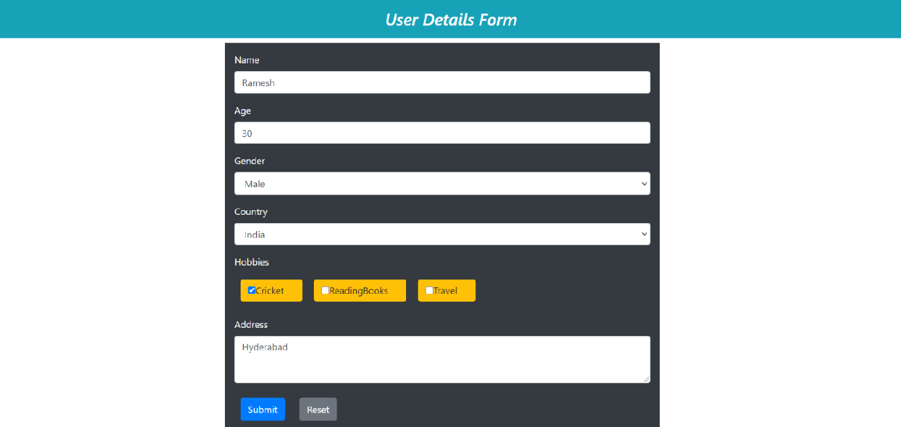

1. Displaying form Fields Submission data as in the below screen with Action buttons and Back Button.

